Luis Garcia

SNHU

[Luis.garcia6@snhu.edu](mailto:Luis.garcia6@snhu.edu)

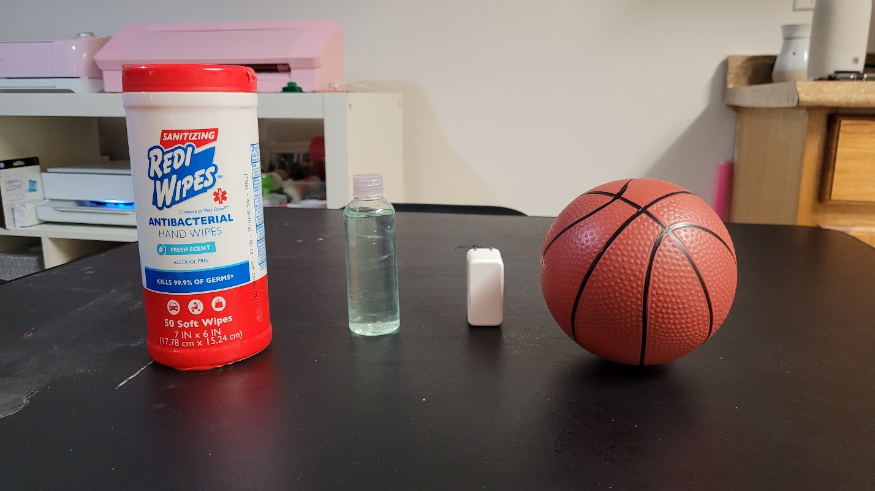

In my picture I choose a basketball, the RediWipes, my phone charger box and for the compose shape the bottle. The basketball will be use as the sphere, the RediWipes will be my cylinder, as the compose shape I will use the bottle since is 2 cylinders one on top of the other and the cube is my phone charger. It is simple yet challenging for me since is the first time learning about computer graphics.

I will be creating the plane where the object will be on and each object representing a shape. The basketball will be my sphere, the RediWipes the cylinder, the charger will be the cube and the bottle will be my compose shape. The bottle is 2 cylinders, one on top of the other. For me it makes sense because I can create different shapes and are my daily use object.